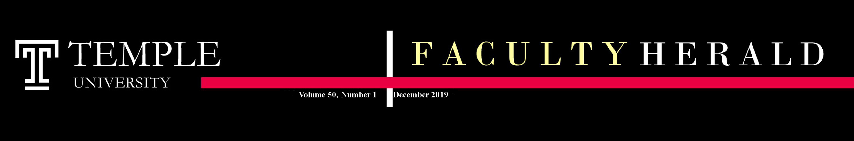

Editorial
Paul S. LaFollette, Jr. - Editor

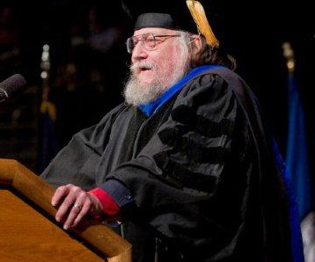
I saw then in my dream, that he went on thus, even until he came at a bottom, where he saw, a little out of the way, three men fast asleep, with fetters upon their heels. The name of the one was Simple, another Sloth, and the third Presumption.
Christian then seeing them lie in this case went to them, if peradventure he might awake them, and cried, You are like them that sleep on the top of a mast, for the Dead Sea is under you--a gulf that hath no bottom. [Prov. 23:34] Awake, therefore, and come away; be willing also, and I will help you off with your irons. He also told them, If he that "goeth about like a roaring lion" comes by, you will certainly become a prey to his teeth. [1 Pet. 5:8] With that they looked upon him, and began to reply in this sort: Simple said, "I see no danger"; Sloth said, "Yet a little more sleep"; and Presumption said, "Every vat must stand upon its own bottom; what is the answer else that I should give thee?" And so they lay down to sleep again, and Christian went on his way. ---John Bunyan The Pilgrim's Progress
The phrase, "Every tub on its own bottom," has become the slogan of the Responsibility Center Model (RCM) for budgeting that Temple now uses. It was first seen in John Bunyan's 1678 allegory The Pilgrim's Progress, uttered by an unpalatable character named Presumption. RCM was initiated at Temple on the presumption that it would provide greater transparency to the budget process and this would be accompanied be greater opportunities for assessment and accountability. It is clear, at least to me, that these hopes have been largely unfulfilled. Continued on page 5..
Temple Preparing for February 2020 Accreditation Visit
By Jodi Levine-Laufgraben, Vice Provost for Academic Affairs, Assessment and Institutional Research
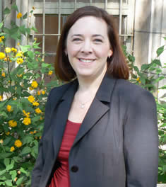
Preparations are well underway for the university’s next regularly-scheduled reaccreditation. Temple is accredited by the Middle States Commission on Higher Education and was last accredited in 2015 via submission of a written periodic review report. Temple is now preparing for a full reaccreditation visit.
President Englert, in his 2018 launch of the reaccreditation process, noted that this is a time a to deepen the university’s understanding of its strengths and opportunities for improvement, while also demonstrating its compliance with the criteria for reaccreditation.
The process, which is being led by a steering committee of faculty, students and staff from across the university, includes a self-study and a campus visit by an external review team. A draft of the self-study was shared with the university community via TUportal for four weeks from mid-October to mid-November. The final report will be submitted to Middle States in advance of the visit.
With the self-study complete, the focus will be on preparations for the February 23-26, 2020 visit by the eight-person evaluation team. While on campus, the team will meet with faculty, students and staff from across the university. Team members will also visit the regional campuses and a member of the visiting team will visit Temple University Japan, Temple’s only location designated as a branch campus by Middle States.
In addition to scheduled meetings, there will be open sessions for faculty, staff and students to meet and talk with members of the visiting teams. Faculty can visit the Middle States Reaccreditation 2020 website https://www.temple.edu/provost/middlestates2020/index.html) to learn more about the reaccreditation process and opportunities to participate. Details of the team visit will be available early n the spring semester.

A Message from the President
By Richard Englert, President, Temple University

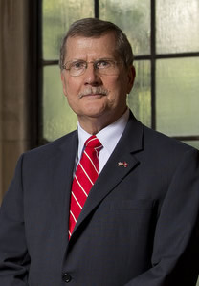
Dear Colleagues:

I am grateful that the Faculty Herald has invited me to include this letter to our outstanding faculty.

In September, I reviewed a number of developments and updates in my State of the University address. I would now like to give you some additional highlights.

I just returned from visits to our long-standing programs in Asia. Our Beasley School of Law LLM degree program celebrated its 20th anniversary. We can all be proud that we teach Chinese jurists, prosecutors, elected officials and others the Western rule of law, and that our students and graduates there are enthusiastic about the quality of the program. In Japan, we celebrated the grand opening of our new building on the campus of Showa Women’s University (SWU) in Tokyo.

Temple University Japan (TUJ) has been in existence for some 36 years. We now have a true college campus environment, one where the diversity of our students is as clearly evident as it is in Philadelphia. We will look for ways to deepen our partnership with SWU. We also will have the facilities to expand our offerings at TUJ, and I urge you to explore ways in which our Main Campus can be linked even more closely with that campus. Opportunities abound for you to create new educational programs and research endeavors, including having faculty from Philadelphia teach in or otherwise visit the campus. Also, our Executive Vice President and Provost, JoAnne Epps, has already begun a search for a new dean since Dean Stronach will be retiring this coming June.

As I mentioned in the State of the University address, our Board of Trustees has created a standing committee on strategic direction and long-range planning, co-chaired by Board member Steve Charles and me. You will be hearing more about our planning efforts and will be asked to participate in helping the university to address the many challenges and opportunities we will be facing in the years ahead, including a shrinking pipeline for traditional age students, the emerging needs of Gen Z students, skepticism among many in the general public about the value of a college education, keen competition from other higher education institutions for resources and students, limited governmental support, increasing student debt levels, rapidly changing technologies and the need to depend more and more upon support from donors and private foundations. Your input on these matters is essential as we continue to ensure that Temple University and its vital mission flourish in the decades ahead.

Also, just a reminder that we continue to prepare for the spring visit by a team for Middle States for our re-accreditation. I want to thank our Middle States steering committee, including co-chairs Rollo Dilworth (Boyer College of Music and Dance) and Jodi Levine Laufgraben (Vice Provost) for their excellent leadership and hard work. They will need your assistance in many ways as we near the visit.

Thank you for all you have done and continue to do for our students, patients and other people we serve. Temple is a premier university because of you, our faculty. You are the ones who ensure our excellence and innovation.

My best,
Dick

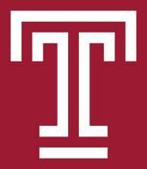
Page 1

A Greeting from the Provost
By JoAnne Epps, Executive Vice President & Provost

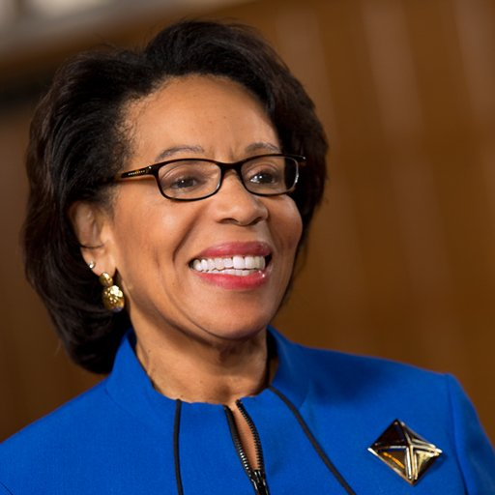
Dear Colleagues,
It seems that we just greeted new and returning students to campus, and already people are thinking about Thanksgiving. I hope you are having a rewarding and enjoyable semester.
I am delighted to have been given the opportunity to write here. I have lots of thoughts and things I’d like to say, far more than space, or your patience, will allow. So I will limit myself to one topic, which will end with a request. Higher education faces more challenges than it has ever faced. Technology is advancing at warp speed, challenging both what we teach and how we teach. Costs are escalating. More and more Americans are questioning the fundamental value of a college degree. And, except for a slight increase in 2025, the number of college age students will continue to decline for the next decade (until 2031, actually). If we care about the students we will educate and the beloved institution where we work, we have to be certain that Temple remains a destination of choice, for students and for faculty. This means we must simultaneously look backwards and forwards. We must look back at our historical mission and the range of accomplishments that brought us to where we are today — a world class institution. Our institution is great because of you. We must look forward towards an institution that delivers the best of a 21st century education, teaching our students to be critical thinkers, society-shapers, and good human beings. So here’s my request. As you teach and as you look ahead to your future courses, consider doing something different, or differently, than you do now. I’m not talking about change just for the sake of change, or change just to be faddish. I’m asking you to ask yourself if you believe the future will look identical to the past. If you think the days ahead might, or most certainly will, look different, what will you change in order to be ready, and even better to stay ready? Temple’s future is in your hands; I know you will do well with it.
JoAnne Epps, Executive Vice President & Provost

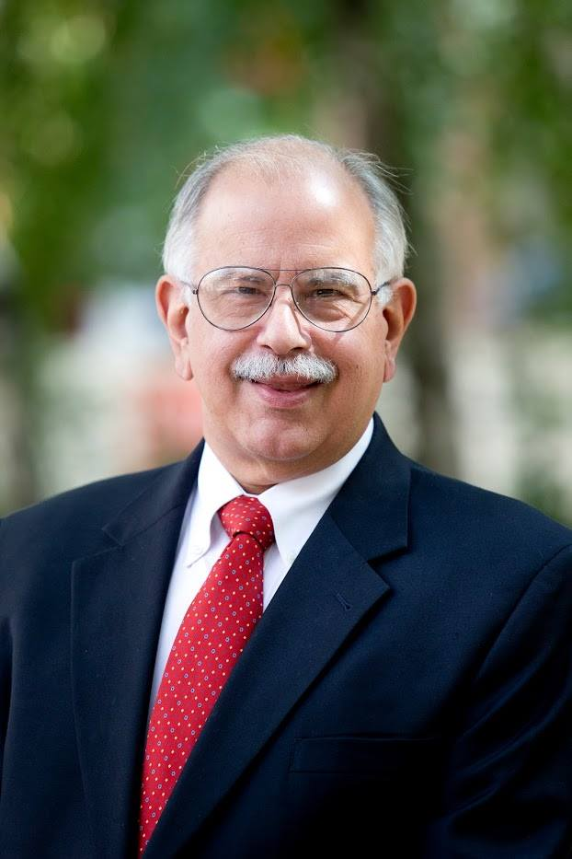
Faculty Senate Service Awards to be Expanded and Upgraded
By Rafael Porrata-Doria, President of the Faculty Senate
After substantial discussion and consideration, the Faculty Senate Steering Committee has decided to expand and upgrade the current Faculty Senate Service Awards program.

Under this new system, the Faculty Senate has created two new Awards to recognize faculty service to their School, the University and the Community. The first award is the “Faculty Senate Outstanding Faculty Service Award” (“FSOFSA”). Three of these awards will be given a year to recognize outstanding service to the University and the community. They will be presented by the Provost and the President and will at the Spring University Research and Teaching Awards ceremony. The second award is the “Faculty Senate Service Awards” (“FSSA”). Eight to thirteen of these awards will be given each year to recognize meritorious service to the University and the community and will be presented at the Spring meeting of the Faculty Senate. Both of these awards are intended to recognize long term, dedicated services.

All full-time current faculty members from all schools and colleges are eligible for consideration for either of these awards. Candidates for either award may be nominated by their school or college, their collegial assembly, one or more of their colleagues or may self-nominate. Individuals nominated by not selected may be nominated again the following year. be nominated by their school or college, their collegial assembly, or one or more of their colleagues. The FSOFSA will not awarded to an individual more than once.

The recipients of both awards will be chosen by a recently appointed FSSC committee, which will shortly publish the specific criteria and deadlines for both awards. This committee will publish the specific criteria and deadlines for nominations shortly.

We anticipate that both awards will be presented during the Spring 2020 semester.

The Opening of the Charles Library
By Joe Lucia, Dean of Libraries
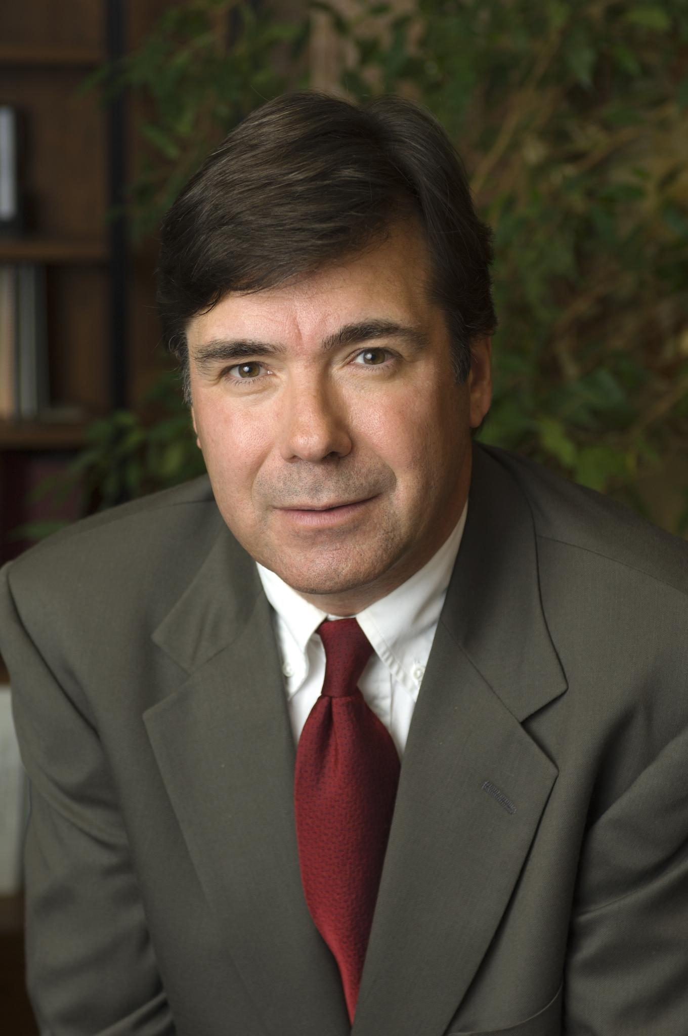
Dear Faculty Colleagues:
The opening of the Charles Library on Temple’s campus at the beginning of this semester has generated excitement and acclaim for the building’s design quality and for its embodiment of our institutional aspirations, as reviews in the Philadelphia Inquirer, The Wall Street Journal, and Architectural Digest illustrate quite dramatically. But if the building is to fulfill its promise as much more than an attractive structure, it must yield new opportunities for our academic community.

Early in the programming process for the facility, our planning group crafted a vision for the building that expresses this ambition:
A catalyst for learning and intellectual engagement, the new Temple University Library cultivates and supports scholars and the scholarly enterprise, connecting people and ideas in a compelling resource- and service-driven environment.

Calling its diverse communities together for inquiry and exploration, interaction and study, this evocative building inspires the discovery, creation, preservation, and sharing of knowledge.

That vision gets to the core of the work we do at the university, especially the work of the faculty. So what in practice can the Charles offer our faculty community? In a practical daily sense, there are new spaces for meeting and collaboration, perhaps most notably the Scholars Study on the fourth floor of the building that is restricted to use by graduate students and faculty. There are also the wide-ranging facilities and services of the Loretta C. Duckworth Scholars Studio on the third floor of the building, which serves as an onramps to a range of services and tools to enhance learning and research, including a VR studio, a Makerspace, a Tech Sandbox, workstations optimized for computational applications in the humanities and social sciences, a collaboration space with breakout rooms, media production facilities and a research and training program in digital methods directed by Prof. Marcus Bingenheimer from the CLA Religion Department and Matt Shoemaker, librarian and Studio manager. The Studio supports Faculty and Graduate Student fellowships and also provides deep technical support for the recently launched interdisciplinary (and inter-college) Graduate Certificate in Cultural Analytics.

The Charles Library also features a number of excellent event venues that support an ambitious agenda of programs (lectures, panel discussions, readings, musical performances, discussion groups, workshops, creative showcases etc.) that is focused on making the intellectual and creative work of our faculty and students broadly visible and broadly available to our community. Many of these events are also captured on video for those who may not be able to attend. You are invited to become our partners in these ongoing endeavors and if you wish to discuss your interests, and when and how they might intersect with our program planning, feel free to contact Sara Wilson (sarawilson@temple.edu), Library Outreach and Communications administrator. As an example of the new kinds of things we are planning in Charles, check out the viewing of the Mercury in Transit view we are hosting for the College of Science and Technology on November 11.

With respect to enhanced facilities for instruction and research, the Special Collections Research Center now features an accessible reading with associated classroom space for secured access to rare and unique materials and a great new museum quality exhibit venue.

Another exciting aspect of the new building is that it houses the Temple University Press and brings the editorial and production expertise of that widely regarded scholarly publishing enterprise close to hand for contact and engagement with faculty and students alike.

I would remiss in this account of what the library offers if I did not stress that it is also the home of an extraordinary staff of subject librarians, technology experts, domain specialists and creative thinkers.

In the broadest sense, first and foremost, the Charles Library is designed to be an interdisciplinary nexus, an intellectual crossroads and public square, that draws researchers and creators out their local environments (the schools and colleges) to engage with each other. One early manifestation of this is the identification of the library as the home for the emerging Science and Technology Studies Network, where faculty from across the institution meet regularly to share their work and discuss big questions about epistemology, philosophy of science, cultural and social perceptions of science, and the impact and affordances of technology and technical systems on human experience. That is but one example of what’s possible and I fully expect many more such initiatives will take shape as conversations around what’s
possible develop over the next year. Continued on page 3.
Page 2
Furthermore, we envision the facility as an informal gathering space as well as a place for formal programs (starting with Stella’s café on a daily basis but perhaps culminating in more structured social events as we live our way into the building’s various features and capacities).

If you have ideas about how the Charles Library can embrace and realize this ambitious vision, please reach out to me or one of my library colleagues for a conversation. Our goal is to say yes and take action on good suggestions wherever possible. Our goal is simple: to support and enhance intellectual community and scholarly engagement for Temple. And we have an inspiring new environment in which to pursue that goal.
Joe Lucia (joe.lucia@temple.edu)
Dean of Libraries
October 31, 2019

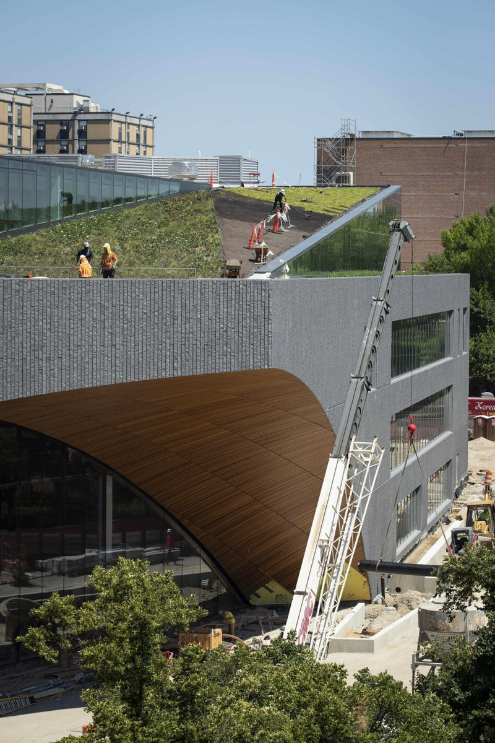

First Chat in the Stacks for 2019-2020
By Kimmika Williams-Witherspoon

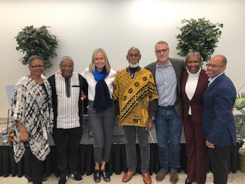
The first “Chat In the Stacks” lecture series of the 2019-2020 academic year, (Thursday, October 10, 2019) focused on common atrocities from which we can all learn in building better futures together.

Entitled, “The TransAtlantic Slave Trade, Holocaust and Other Crimes Against Our Himanity — A Panel Discussion on Modern-day Genocide,” panel participants for the standing room only crowd included (from left) Journalism Professor Karen Turner, Dr. Molefi Asante, Chair of Temple’s Africology and African American Studies Department; Ulrika Citron, a member of Klein’s Board of Visitors and daughter of a Holocaust survivor; Gary Shepherd, a broadcast pioneer who just returned from Ghana, West Africa as a departure point of thousands of enslaved Africans; Todd Bernstein, President of Global Citizen who recently returned from visiting the notorious death camps of Auschwitz, Poland, Along with Associate Professor of Urban Theater and Community Engagement Dr. Kimmika Williams-Witherspoon and Professor and Diversity Advisor to the Office of the Dean for Klein College of Media and Communication David W. Brown, co-chairs of the Faculty Senate Committee on the Status of Faculty of Color (FOC).
“Chat in the Stacks” — which is presented as a partnership between the University Libraries and the Faculty Senate Committee on the Status of Faculty of Color — is part of the “Beyond the Page” series, which presents engaging panels focusing on modern topics, issues, and trends.

TAUP/Administration Negotiations: impressions from the Table Team By Jeffrey Solow, Professor, Boyer College of Music and Dance
The article below was completed on November 11. As most readers have probably heard by now, TAUP and Temple’s administration signed a Tentative Agreement at about 11:30pm on November 24, making its time-sensitive content obsolete, assuming both sides ratify the agreement. However, it remains important for everyone to understand how the negotiation process proceeded as we will be there again in 4 years. Equally important to understand is just because we arrived at an agreement, that does not mean it contains everything we wanted and fought for. TAUP’s officers and the rest of the Table Team determined that the set of compromises we had reached, though falling short of our goals on a number of issues, included significant progress and gains for our the members of our Bargaining Unit. The determining factor in our decision was the recognition that accepteding the agreement as reached on Monday night, it would make life better for our members while continuing to negotiate and agitate would not likely improve the outcome and risked a deal worse than what we signed on Monday. If we want to do even better at the next negotiations, we need more dues-paying members. More than well-researched arguments, well-crafted proposals, and well-attended rallies, it's membership percentage that gives a union power at the negotiating table. Jeffrey Solow
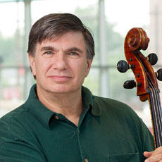
As a musician, I grew up with an appreciation of labor unions: a history of strong musicians’ unions dramatically improved life for musicians throughout the United States. Hence, as soon as I came to Temple in 1989, I joined TAUP. Those with a long enough institutional memory will recall that my arrival was just in time to go on strike. An example of history’s well-recognized cycles, in 1990, Temple’s administration was, for the first time, insisting on a $260 faculty contribution to healthcare costs – TAUP was resisting. The administration’s current proposal would likewise break new ground for the faculty’s contribution to healthcare: not only would premiums increase (4% for families, 2% for individuals) and co-pays for specialists (currently $20, rising to $40), but for the first time there would be a deductible ($500 for families, $250 for individuals) – TAUP is resisting.

Of course, some things are new in the ongoing negotiations, both positive and negative. On the positive side, we insisted on Open Bargaining, which welcomes faculty members to observe the negotiation sessions and contribute their views to the Table Team when we caucus during session breaks. New on the negative side is a concerted effort on the administration’s part to weaken and even break the union, as well as make it more difficult for TAUP to represent and protect the members of our Collective Bargaining Unit. The administration previously succeeded in removing chairs from the CBU; this go ’round they tried to remove program directors and Academic Professionals. (Although they took removing Program Directors off the table in terms of this contract, they still have the right to pursue it in Harrisburg and it is likely that after negotiations we will have to fight it out at the Pennsylvania Labor Relations Board.) They are trying to eliminate our on-campus office space in order to force us to spend a portion of our members’ dues on rent and make it harder for faculty to meet with TAUP representatives. They are proposing to eliminate union service from merit consideration, to eliminate course-releases for our officers who spend many hours enforcing the rights of our members, and to eliminate our access to new hires at HR orientations so that we can to inform them of their rights under the contract.

For those who have not attended the negotiations, here is a small snapshot. All sessions are at the 201 Philadelphia Hotel (the administration claimed they wanted to use an off-site hotel because they were worried about possible protests or disruptions if they were on campus, but I think the real reason was because it makes it more difficult for faculty observers to attend.) We sit on opposite sides of a long table with our mediator Bill Gross, at one end. His job is to get us across the finish line of a new contract by being an impartial go-between. (Observers sit behind us along our side of the room.)
William Gross - Director, Bureau of Mediation at Commonwealth of Pennsylvania
<http://www.pasboerc.org/newsfuploads/2070themediationprocess.pdf>
Continued on page 4
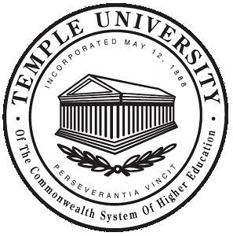

Page 3

The administration's team consists of five people:
- Sharon Boyle (Lead Negotiator) - Associate Vice President, Human Resources
- Susan Smith - Deputy University Counsel <https://counsel.temple.edu/about/directory/susan-b-smith>
- Kevin Delaney - Vice Provost for Faculty Affairs <https://liberalarts.temple.edu/academics/faculty/delaney-kevin>
- Monica Washington - Director of Labor Relations <https://www.temple.edu/hr/departments/employeerelations/staff.html>
- Shannon Farmer - Partner at Ballard Spahr LLP <https://www.ballardspahr.com/people/attorneys/farmer_shannon>

TAUP’s Table Team is larger because it has one representative and one back-up person for each constituency represented by TAUP, in addition to the officers. Most of us need to continue teaching/serving our students and meeting our other Temple obligations, in addition to preparing for and participating in the negotiations, so generally, not all the members of our team are present at every session. (The Table Team also meets regularly between sessions.)

- Shelly Snyder - Lead Negotiator. Staff Rep at American Federation of Teachers, PA
- Steve Newman, Tenured/Tenure Track, CLA, TAUP President
- Jennie Shanker, Adjunct, Tyler, TAUP Vice President
- Norma Corrales-Martin, Non-Tenure Track, CLA, TAUP Treasurer
- Fred Rowland, Librarian, TAUP Executive Committee, Chair Library Constituency Council
- Donald Wargo, Non-Tenure Track, CLA, TAUP Executive Committee, Chair NTT Constituency Council
- Paul LaFollette, Tenured/Tenure Track, CST
- Jeffrey Solow, Tenured/Tenure Track, BCMD, TAUP member, Alternate TT
- Kolson Schlosser, Non-Tenure Track, CLA, NTT Constituency Council member, Alternate NTT
- Andrew Dudenbostel, Adjunct, FMA, Adjunct Constituency Council member
- Leanne Finnigan, Librarian, Alternate
- Jill Luedke, Librarian, Alternate
- Nia Jackson, Academic Professional, CLA
- John Campbell-Orde - TAUP Consultant
- Jenna Siegel - TAUP Organizer

About 30 minutes before each session the Table Team and faculty observers gather to go over the protocols and the game-plan for the day. Once the session begins, most of the talking is done by Sharon Boyle on the administration’s side and by Steve, Jennie, and Shelly on our side (with input from other Table Team members as appropriate). During breaks we discuss what happened during the negotiations, share our observations and views, and usually both Shelly and John offer their sage counsel gained through years of experience as negotiators.

We have made progress, having signed over 20 tentative agreements on important issues. Here are a few:
- Student feedback forms will no longer be used as the primary criterion for personnel decisions
- The criteria for prestigious fellowships that trigger salary top-ups will be decided by individual college/schools, with input from faculty
- There will be a new fact-finding step for grievances
- NTTs will have a chance to apply for sabbaticals earlier
- NTTs will be guaranteed representation on committees making decisions on their merit and sabbaticals
- Librarians will have input into criteria for promotion to L4, the highest level
- Academic Professionals will have a reduced probationary period and a clearer merit process
- Adjuncts will have:
  - a new evaluation process that can lead to promotion, raises, and multi-semester appointments. It stipulates that multiple methods of assessment must be used, not just student feedback forms.
  - pay minima associated with each rank plus an explanation as to how their rank and pay were set, which improves their ability to negotiate
  - a provision that will make it easier for them to receive unemployment compensation during semesters they are not teaching.

However, the administration is still resisting our proposals on increasing the number of Tenure-Track faculty, job security for NTT faculty, meaningful parental leave for Librarians and Academic Professionals; and they are ignoring our proposals on childcare and tuition benefits at other universities. Plus, along with healthcare as mentioned above, the other elephant in the room is raises. The administration’s paltry proposal for across-the-board salary and merit increases for full-time faculty, and their proposed raises for adjuncts who are at and above the minimum remain well below the projected rate of inflation.

Several of our team members contributed short statements about the negotiations:

“Hi, I'm Donald Wargo. I'm from the Econ Dept. in CLA and I'm on the TAUP negotiating team. I feel we have made some progress on the non-economic issues but we are still far apart on the economic issues (Across-the-Board raise, Merit, Health Insurance costs, etc.) But do not worry, the negotiating team is prepared to ‘negotiate till the owls come home’ in order to get a fair contract for our members.”

“My name is Nia Jackson and I am an Academic Professional who has worked at Temple for 3-1/2 years. I joined the table team as early negotiations began. I quickly learned how the staunch defense of both TAUP's and the Administration’s contrasting interests is often the cause of significant friction, while also leaving a seemingly small amount of compromising space. Therefore, we must be strategic in the content and delivery style of our proposals in order to achieve the results we desire for all of our TAUP members.”

Kolson Schlosser - Department of Geography and Urban Studies, CLA: “Negotiations are a fascinating and arduous process, something we should all strive to participate in!”

“I'm Fred Rowland, research librarian at the Temple University Libraries supporting the disciplines of classics, economics, philosophy, and religion. As a member of the Table Team I am impressed by the hard work and careful preparation of our lead negotiators. These are difficult negotiations and we are making deliberate progress in coming to terms on our economic and non-economic proposals.”

Jennie Shanker; Adjunct, Former NTT and Interim Chair, Tyler School of Art, Vice President of TAUP: “I've been at Temple for over 15 years and have never seen this level of participation from colleagues in fighting against working conditions that we know are wrong. We want to work in a quality environment and the lack of tenured colleagues, lack of job security and the pressures of RCM, put us at a disadvantage and do not allow us to work to the best of our abilities. We shouldn't have to fight our employer to be able to do our jobs well, but this negotiation proves that if we have to, we will.”

Steve Newman; Tenured, CLA, President of TAUP: “These negotiations have been trying, but I continue to be inspired by the dedication and intelligence of our Table Team, other leaders in the Union, our staff, and members who have attended open bargaining and by the support from our graduate and undergraduate students, other unions, and elected officials. We have made significant progress on many issues, and I am confident that we can win the other provisions we need by continuing to fight for our values at the table and away from it and by working with the administration wherever possible for a mutually acceptable agreement.”

We still have a long way to go in order to achieve a fair contract, especially regarding wages and healthcare, and Temple must stop trying to attack and weaken the union. You can keep up-to-date on the progress of the negotiations by reading our Bulletins and checking the TAUP website: <https://taup.org/>

We know that we have strong faculty and student support, but visible faculty support is extremely effective and helpful. Please come and observe the negotiations. In addition to being important, it is interesting! You are sure to be as impressed and proud of our tremendous union leadership as I am.

Missing Temple Owl Returns to Campus
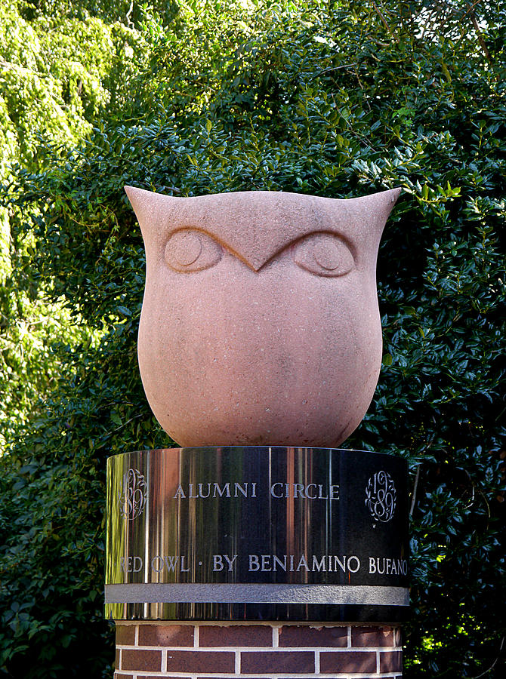The thoughtful Temple Owl, missing since it was replaced by the frightening owl, has flown back to campus. It is now nesting diagonally across from and with its back turned to the newer, fiercer owl. Your editor is happy for the return, for he believes this studious owl is a more appropriate symbol for a scholarly institution.

Page 4

Editorial (Continued from page 1)
Many, perhaps most schools and colleges have failed to create the mandated faculty budget committees. Of those that have created such committees, at least some do not meet. Programs such as Honors and Gen-Ed which are not tied to specific schools or colleges receive no income from the courses for which they are responsible. There is increasing competition between schools for undergraduate credit hours. This is sometimes manifest by changing major requirements in ways that discourage undergraduates from using free electives to explore disciplines distant from their majors. Interdisciplinary courses that cross college boundaries are difficult, perhaps impossible to explore. RCM has indeed encouraged entrepreneurial endeavors, but too often these endeavors, while they may benefit a particular school, operate to the disservice of our undergraduate students. The administration has "studied" the impact of RCM and found it to be operating adequately. It is time for us as the faculty, working through the Faculty Senate, to begin our own process of evaluation of the impact of this budget model and develop proposals for its improvement or, perhaps, abandonment.

